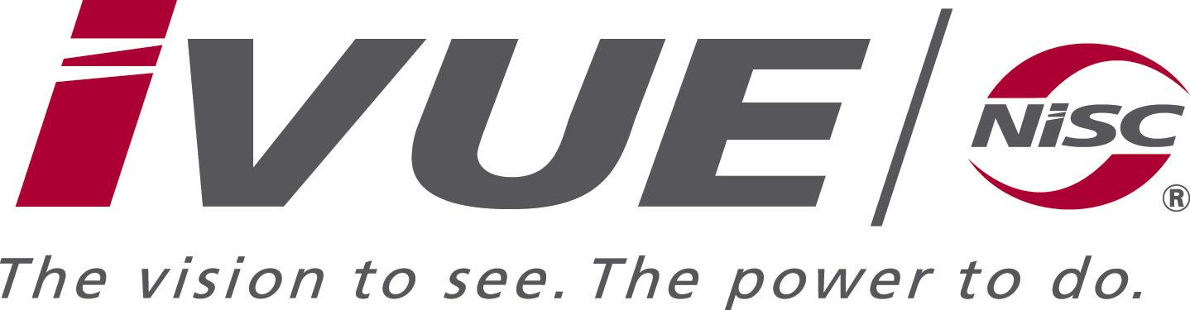
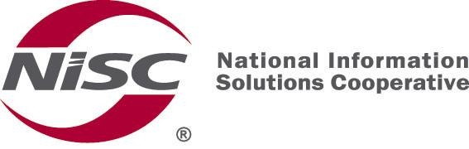

September 9th, 2013

Mr. Kevin Schroeder
Tri-County Communications Cooperative
417 5th Avenue N
Strum, WI 54770

Dear Kevin,

NISC would like to make you aware that the initial warranty for the Dell equipment running NISC software has expired or will expire really soon. We are able to obtain from Dell an extension of the warranty services for the following Dell servers:

The price for the extension of the warranty services to 9/15/2014 for the PowerEdge T610 Database Server (service tag 9VQWVK1 is $1,280.00. These services are a continuation 4hr 7x24 services currently provided for this equipment.
An active SuSE Linux subscription is required for NISC to push important security updates out to the server(s). SuSE Linux 1-yr subscription renewal member cost is additional $300 per server. So you w
The price for the extension of the warranty services to 9/15/2014 for the PowerEdge R300 Ebill Server (service tag 9QDJVH1 is $480.00. These services are a continuation Next Business Day services currently provided for this equipment.
An active SuSE Linux subscription is required for NISC to push important security updates out to the server(s). SuSE Linux 1-yr subscription renewal member cost is additional $300 per server. So you would be getting this for 1 year, $300.

To approve warranty extension(s), please check the box(s) above that you would like to extend, sign and return at your earliest convenience. The signed letters may be scanned and emailed to karen.theis@nisc.coop or faxed to (636) 755-2501, attention: Karen Theis.

Thanks for the opportunity to be of service to: Tri-County Communications Cooperative

Sincerely,

Karen Theis, Sales Support Consultant
NATIONAL INFORMATION SOLUTIONS COOPERATIVE

Please secure the warranty services extension as noted above.
Tri-County Communications Cooperative

______________________________ Authorized Signature

______________________________ Title

______________________________ Date

